STAT 200 Week 6 Homework Problems
9.1.2
Many high school students take the AP tests in different subject areas. In 2007, of the 144,796 students who took the biology exam 84,199 of them were female. In that same year, of the 211,693 students who took the calculus AB exam 102,598 of them were female ("AP exam scores," 2013). Estimate the difference in the proportion of female students taking the biology exam and female students taking the calculus AB exam using a 90% confidence level.
Solution
$n_{1}=144,796$
$n_{2}=211,693$
$x_{1}=84,199$
$x_{2}=102,598$
$$C=1-α=1-0.9=0.1, Hence the critical region refers towards the area in the tail and the confidence in the middle area$$
$x_{1}=number of female students taking the biology exam$
$x_{2}=number of female students taking the calculus AB exam$
$P_{1}= proportion of female students taking the biology exam$
$P_{2}=proportion of female students taking the calculus AB exam$
The difference in proportion =$P_{1}-P_{2}$
Finding proportional values
Proportional values for the students taking biology exam
${p̂}_{1}=\frac{x_{1}}{n_{1}}\frac{84199}{144796}=0.5815$
${q̂}_{1}=1-{\hat{p}}_{1}=1-0.5815=0.4185$
Proportional values for the female students taking AB exam
${\hat{p}}_{2}=\frac{x_{2}}{n_{2}}=\frac{102598}{211693}=0.4847$
${q̂}_{2}=1-{\hat{p}}_{2}=1-0.4847=0.5153$
The critical value that gives the percentage of confidence interval of 90% is in the middle area of the graph
The area of interest=$1-α=1-0.9=0.1,but there are two tails , hence each tail=0.05$
$z-critical value=1.645$

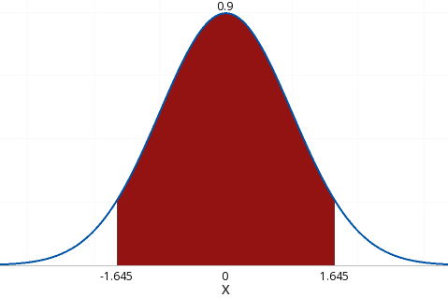

The margin of error(E)=$z_{c}\sqrt{\frac{{p̂}_{1}{q̂}_{1}}{n_{1}}}+\frac{{\hat{p}}_{2 }{q̂}_{2} }{n_{2}}=1.645\sqrt{\frac{(0.5815×0.4185)}{144796}}+\frac{(0.4847+0.5153)}{211693}=0.0028$
$CI \left(P_{1}-P_{2}\right)=\left({p̂}_{1}-{\hat{p}}_{2 }\right)-E<\left({\hat{p}}_{1}-{\hat{p}}_{2 }\right)+E=$(0.5815 − 0.4847) − 0.0028 <$\left({p̂}_{1}-{\hat{p}}_{2 }\right)$< (0.5815 − 0.4847) + 0.0028$=$0. 0941 < $\left({p̂}_{1}-{\hat{p}}_{2 }\right)$ < 0. 0996
Therefore, the proportion of female students taking biology exam is between 9.41% and 9.96% higher than the female students taking AB exam.

9.1.5
Are there more children diagnosed with Autism Spectrum Disorder (ASD) in states that have larger urban areas over states that are mostly rural? In the state of Pennsylvania, a fairly urban state, there are 245 eight year olds diagnosed with ASD out of 18,440 eight year olds evaluated. In the state of Utah, a fairly rural state, there are 45 eight year olds diagnosed with ASD out of 2,123 eight year olds evaluated ("Autism and developmental," 2008). Is there enough evidence to show that the proportion of children diagnosed with ASD in Pennsylvania is more than the proportion in Utah? Test at the 1% level.
$n_{1}=18,440$
$n_{2}$=$2,123$
$x_{1}=245$
$x_{2}=45$
$α=0.01$
Hypothesis:
Null hypothesis:$H0: p_{1} =p_{2} or H0: p_{1} - p_{2} = 0$
Alternative hypothesis : Ha: $p_{1}$ > $p_{2}$ or Ha: $p_{1}$ − $p_{2}$ > 0
Values of sample proportion:
${p̂}_{1}=\frac{x_{1}}{n_{1}}=\frac{245}{18440}=0.0133$
${q̂}_{1}=1-{\hat{p}}_{1}=1-0.0133=0.987$
${\hat{p}}_{2}=\frac{x_{2}}{n_{2}}=\frac{45}{2123}=0.0212$
${q̂}_{2}=1-{\hat{p}}_{2}=1-0.0212=0.979$
Finding the pooled proportions p̅ and q̅
$\overline{p}=\frac{245+45}{18440+2123}=0.0141$
$\overline{q}=1-\overline{p}=1-0.0141=0.986$
Calculating the statistics:
$z=\frac{\left(p_{1}-p_{2}\right)-\left(p_{1}-p_{2}\right)}{\sqrt{\frac{\overline{p} \overline{q}}{n_{1}}}+\frac{\overline{p}\overline{q}}{n_{2}}}$
But $H_{0}:P_{1}-P_{2=0}$
Z$=\frac{\left(0.0133-0.0212\right)-0}{\sqrt{\left(\frac{0.0141×0.9859}{18440}+\frac{0.0141×0.9859}{2123}\right)}}=-2.927$
Also, $H_{a} :p_{1}-p_{2}>0$
The p-value$1-Norm.DSIT\left(-2.927,TRUE\right)=0.9983$
Because the p-value is more than the significance level of 0.01, the null hypothesis should be rejected. Is there is no enough evidence to show that the proportion of children diagnosed with ADS in Pennsylvania is more than the proportion in Utah.

9.2.3
All Fresh Seafood is a wholesale fish company based on the east coast of the U.S. Catalina Offshore Products is a wholesale fish company based on the west coast of the U.S. Table #9.2.5 contains prices from both companies for specific fish types ("Seafood online," 2013) ("Buy sushi grade," 2013). Do the data provide enough evidence to show that a west coast fish wholesaler is more expensive than an east coast wholesaler? Test at the 5% level.
Table #9.2.5: Wholesale Prices of Fish in Dollars
Fish | All Fresh Seafood Prices | Catalina Offshore Products Prices
Cod | 19.99 | 17.99
Tilapi | 6.00 | 13.99
Farmed Salmon | 19.99 | 22.99
Organic Salmon | 24.99 | 24.99
Grouper Fillet | 29.99 | 19.99
Tuna | 28.99 | 31.99
Swordfish | 23.99 | 23.99
Sea Bass | 32.99 | 23.99
Striped Bass | 29.99 | 14.99

Solution
We are given :$n_{1}=9 and α=0.05$
$x_{1}=wholesale prices from west coast fishery$
$x_{2}=wholesale prices from east coast fishery$
$μ_{1}=mean wholesale prices from west coast fishery$
$μ_{2}=mean wholesale prices from east coast fishery$
Hypothesis:
Let the null hypothesis be stated as $H0: μ_{1}= μ2$ , and alternative hypothesis as$Ha: μ_{1} > μ2=μ_{d}>0$
Calculating mean and standard deviation:
Fish | All Fresh Seafood Prices | Catalina Offshore Products Prices | Difference($x_{1}$-$x_{2}$)
Cod | 19.99 | 17.99 | 2.00
Tilapi | 6.00 | 13.99 | -7.99
Farmed Salmon | 19.99 | 22.99 | -3.00
Organic Salmon | 24.99 | 24.99 | 0.00
Grouper Fillet | 29.99 | 19.99 | 10.00
Tuna | 28.99 | 31.99 | -3.00
Swordfish | 23.99 | 23.99 | 0.00
Sea Bass | 32.99 | 23.99 | 9.00
Striped Bass | 29.99 | 14.99 | 15.00
Mean | 24.102 | 21.66 | 2.446
Standard deviation | 8.17 | 5.59 | 7.399
Determining the statistic
$$t=\frac{Mean of difference-μ_{d}}{\frac{Standard deviation of difference }{\sqrt{n}}}=\frac{2.446-0}{\frac{7.399}{\sqrt{9}}}=0.99986$$
Using excel to find the p-value
$p-value=“=T.DIST.RT(0.9915, 9-1)” = 0.175$
Because our p-value (0.175) is greater than the significance level (0.05) we accept the null hypothesis. Therefore, there is no sufficient evidence to show that west coast fish wholesalers are more expensive than east coast wholesalers.
9.2.6
The British Department of Transportation studied to see if people avoid driving on Friday the 13th. They did a traffic count on a Friday and then again on a Friday the 13th at the same two locations ("Friday the 13th," 2013). The data for each location on the two different dates is in table #9.2.6. Estimate the mean difference in traffic count between the 6th and the 13th using a 90% level.
Table #9.2.6: Traffic Count
Dates | 6th | 13th
1990, July | 139246 | 138548
1990, July | 134012 | 132908
1991, September | 137055 | 136018
1991, September | 133732 | 131843
1991, December | 123552 | 121641
1991, December | 121139 | 118723
1992, March | 128293 | 125532
1992, March | 124631 | 120249
1992, November | 124609 | 122770
1992, November | 117584 | 117263

Solution
We are given;
N=10
$C=1-α=1-0.90=0.10$
Let:
$x_{1=}traffic count on Friday the 6th$
$x_{2}=traffic count on Friday the 13th$
$μ_{1}=mean traffic count on Friday the 6th$
$μ_{2}=mean traffic count on Friday the 13th$
Calculating sample statistic and Confidence interval using excel
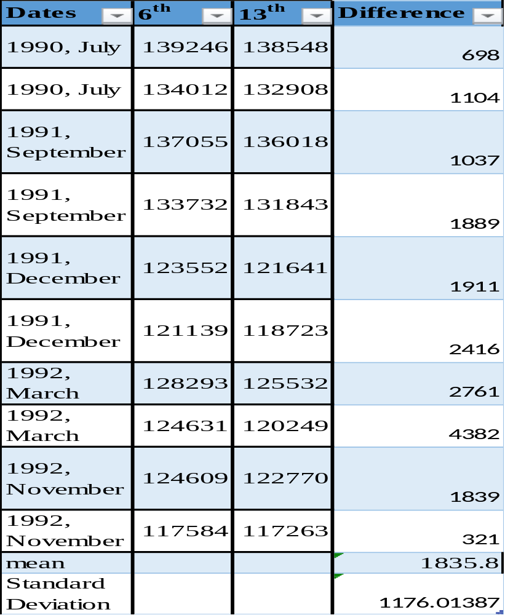$Mean of difference(\overline{d})= 1835.8$
$standard deviation of the differences (s_{d}) = 1176.01$
Calculating the margin of error
$C = 1 – α = 1 = 0.9 = 0.1 in both tails$
Determining critical t-value using excel
$=T.INV.2T(0.1, 10-1) = 1.833$
Margin of error(E)$=t_{c}\frac{S_{d}}{\sqrt{n}}=1.833\frac{1176.01}{\sqrt{10}}=681.70$
Confidence interval(CI)$=\overline{d}- E < μ_{d} < \overline{d}+ E=1835.8 - 681.7 < μ_{d}< 1835.8 + 681.7$
CI=$1154. 1 < μ_{d} < 2517. 5$
Therefore , The mean difference in traffic counts between Friday $6^{th}$ and
Friday ${13}^{th}$ ranges between 1154.1 and 2517.5.
9.3.1
The income of males in each state of the United States, including the District of Columbia and Puerto Rico, are given in table #9.3.3, and the income of females is given in table #9.3.4 ("Median income of," 2013). Is there enough evidence to show that the mean income of males is more than of females? Test at the 1% level.

Table #9.3.3: Data of Income for Males
$42,951 | $52,379 | $42,544 | $37,488 | $49,281 | $50,987 | $60,705
$50,411 | $66,760 | $40,951 | $43,902 | $45,494 | $41,528 | $50,746
$45,183 | $43,624 | $43,993 | $41,612 | $46,313 | $43,944 | $56,708
$60,264 | $50,053 | $50,580 | $40,202 | $43,146 | $41,635 | $42,182
$41,803 | $53,033 | $60,568 | $41,037 | $50,388 | $41,950 | $44,660
$46,176 | $41,420 | $45,976 | $47,956 | $22,529 | $48,842 | $41,464
$40,285 | $41,309 | $43,160 | $47,573 | $44,057 | $52,805 | $53,046
$42,125 | $46,214 | $51,630

Table #9.3.4: Data of Income for Females
$31,862 | $40,550 | $36,048 | $30,752 | $41,817 | $40,236 | $47,476 | $40,500
$60,332 | $33,823 | $35,438 | $37,242 | $31,238 | $39,150 | $34,023 | $33,745
$33,269 | $32,684 | $31,844 | $34,599 | $48,748 | $46,185 | $36,931 | $40,416
$29,548 | $33,865 | $31,067 | $33,424 | $35,484 | $41,021 | $47,155 | $32,316
$42,113 | $33,459 | $32,462 | $35,746 | $31,274 | $36,027 | $37,089 | $22,117
$41,412 | $31,330 | $31,329 | $33,184 | $35,301 | $32,843 | $38,177 | $40,969
$40,993 | $29,688 | $35,890 | $34,381

Solution
We are given , $n_{1}$=$52$
$n_{2}$=$52$
$α=0.01$
Let:
$x_{1}=income of a male in 2013$
$x_{2}=income of a female in 2013$
$μ_{1}=mean income of a male in 2013$
$μ_{2}$=$mean income of a female in 2013$
Hypothesis
Null hypothesis=$H_{0}: μ_{1} - μ_{2} = μ_{d}= 0$
Alternative hypothesis=$H_{a}:μ_{1}-μ_{2}=μ_{d}>0$
Calculating Sample Statistic-value, and t-statistic
- Finding Sample statistic using excel

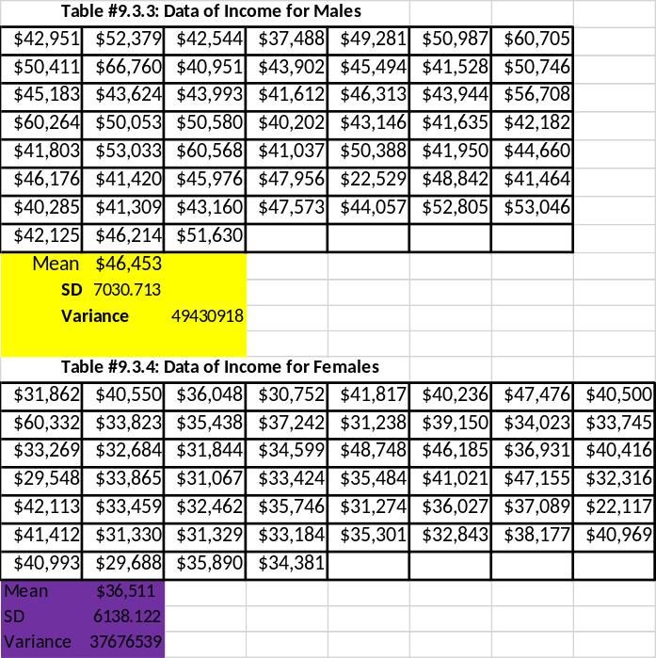
${x̅}_{1}= \$46,453, S_{1}= \$7,030.71, {S_{1}}^{2}=49430918$
${x̅}_{2}=36511,S_{2}=6138.122, {{ S}_{2}}^{2}=37676539$

We can use the F-Distributions to Check if the standard deviation ratio is greater than or equal to variance ratio using F-distribution test:

$=1-F.DIST(49,430,918/37,676,539, 52-1, 52-1, TRUE) = 0.1677$

Calculating the pooled Standard deviation
Assuming that variances are equal
$s_{p}$=$\frac{\left(52-1\right)49430918+\left(52-1\right)37676539}{\left(52-1\right)+(52-1)}=6599.0$
Determining the t-statistics
$t=\frac{\left({\overline{x}}_{1}-{\overline{x}}_{2}\right)-(μ_{1}-μ_{2})}{s_{p}\sqrt{\left(\frac{1}{n_{1}}+\frac{1}{n_{2}}\right)}}=\frac{\left(46453-36511\right)-(0)}{6599\sqrt{\left(\frac{1}{52}+\frac{1}{52}\right)}}=7.68$
Degree of Freedom(df)=$\left(52-1\right)+\left(52-1\right)=102$
Calculating p-value using T-distribution function in excel
P-value $“=T.DIST(7.682, 102, TRUE)”$=$4.96×{10}^{-11}$
Because our p-value is greater than the significance, the null hypothesis should be rejected. This indicates that there is sufficient evidence to show that the mean income of males is more than of females.
9.3.3
A study was conducted that measured the total brain volume (TBV) (in 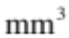) of patients that had schizophrenia and patients that are considered normal. Table #9.3.5 contains the TBV of the normal patients and table #9.3.6 contains the TBV of schizophrenia patients ("SOCR data oct2009," 2013). Is there enough evidence to show that the patients with schizophrenia have less TBV on average than a patient that is considered normal? Test at the 10% level.

Table #9.3.5: Total Brain Volume (in ) of Normal Patients
1663407 | 1583940 | 1299470 | 1535137 | 1431890 | 1578698
1453510 | 1650348 | 1288971 | 1366346 | 1326402 | 1503005
1474790 | 1317156 | 1441045 | 1463498 | 1650207 | 1523045
1441636 | 1432033 | 1420416 | 1480171 | 1360810 | 1410213
1574808 | 1502702 | 1203344 | 1319737 | 1688990 | 1292641
1512571 | 1635918

Table #9.3.6: Total Brain Volume (in ) of Schizophrenia Patients
1331777 | 1487886 | 1066075 | 1297327 | 1499983 | 1861991
1368378 | 1476891 | 1443775 | 1337827 | 1658258 | 1588132
1690182 | 1569413 | 1177002 | 1387893 | 1483763 | 1688950
1563593 | 1317885 | 1420249 | 1363859 | 1238979 | 1286638
1325525 | 1588573 | 1476254 | 1648209 | 1354054 | 1354649
1636119

Solution
We are given : $n_{1}$ = 32
$n_{2}$ = 31
α = 0.10
Let:
$x_{1}$ = total brain volume (TBV) of patients that are considered normal
$x_{2}$ = TBV of patients that had schizophrenia
$μ_{1}$ = mean TBV of patients that are considered normal
$μ_{2}$ = mean TBV of patients that had schizophrenia
Hypothesis
Null hypothesis=$H_{0}: μ_{1} = μ_{2}$
Alternative hypothesis=$H_{a}: μ_{1}> μ_{1}$
Finding the sample mean, standard deviation and variance using excel
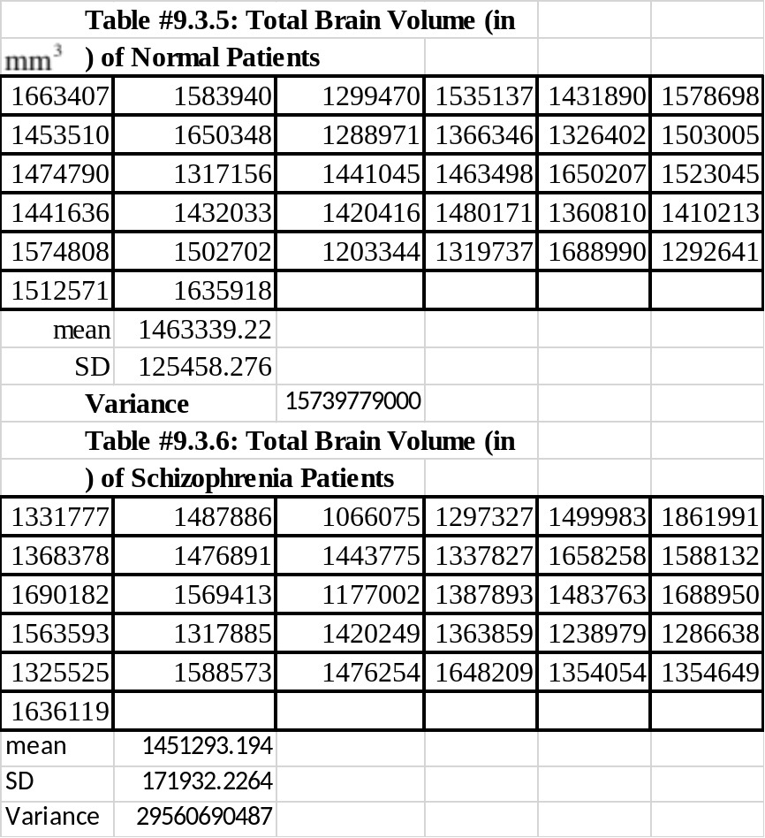

Sample Mean and standard deviation
${x̅}_{1} = 1,463,339.2 mm3$ $; s_{1}= 125,458.3 mm3$

${x̅}_{2}=1,451,293.2 mm3; s_{2}= 171,932.2 mm3$
Sample variance:
${s_{1}}^{2}= 15,739,779,000$
${s_{2}}^{2}= 29,560,690,487$
Checking if $(\frac{{σ_{2}}^{2}}{{σ_{1}}^{2}}>\frac{{s_{2}}^{2}}{{s_{1}}^{2}})≥0.05$ using F-distribution test:
$=1-F.DIST(29,560,690,487/15,739,779,000, 31-1, 32-1, TRUE) = 0.0430$

Because($\frac{{σ_{2}}^{2}}{{σ_{1}}^{2}}>\frac{{s_{2}}^{2}}{{s_{1}}^{2}}=0.043<0.05$ it cannot be assumed that variances are equal.

$t=\frac{\left({\overline{x}}_{1}-{\overline{x}}_{2}\right)-(μ_{1}-μ_{2})}{\sqrt{\left(\frac{{s_{1}}^{2}}{n_{1}}+\frac{{s_{2}}^{1}}{n_{2}}\right)}}=\frac{\left(1,463,339.2 - 1,451,293.2)\right)-(0)}{\sqrt{\left(\frac{15,739,779,000}{32}+\frac{29,560,690,487}{31}\right)}}=0.317$
Finding the degree of freedom(df)
Df=$\frac{{\left(A+B\right)}^{2}}{\frac{A^{2}}{n-1}+\frac{B^{2}}{n-1}}$
A=$\frac{{S_{1}}^{2}}{n_{1}}=\frac{15,739,779,000}{32}=491,868,093.7 and B=\frac{{S_{2}}^{2}}{n_{2}}=\frac{29,560,690,487}{31}=953570660.8$
Df=$\frac{{\left((491,868,093.7 + 953,570,660.8\right)}^{2}}{\frac{491,868,093.7}{32-1}+\frac{953570660.8}{31-1}}=54.90$
Finding p-value using T-distribution function in excel
p-value=$“=T.DIST(0.317, 54.90, TRUE)” = 0.6238$
We fail to reject the null hypothesis because the p-value (0.6238) is greater than the significance level (0.10). Therefore, there is no sufficient evidence to show that the patients with schizophrenia have less TBV on average than a patient that is considered normal.
9.3.4
A study was conducted that measured the total brain volume (TBV) (in ) of patients that had schizophrenia and patients that are considered normal. Table #9.3.5 contains the TBV of the normal patients and table #9.3.6 contains the TBV of schizophrenia patients ("SOCR data oct2009," 2013). Compute a 90% confidence interval for the difference in TBV of normal patients and patients with Schizophrenia.

Solution
We are given : $n_{1}$ = 32
$n_{2}$ = 31
α = 0.10
Let:
$x_{1}$ = total brain volume (TBV) of patients that are considered normal
$x_{2}$ = TBV of patients that had schizophrenia
$μ_{1}$ = mean TBV of patients that are considered normal
$μ_{2}$ = mean TBV of patients that had schizophrenia

Sample Mean and standard deviation
${x̅}_{1} = 1,463,339.2 mm3$ $; s_{1}= 125,458.3 mm3$

${x̅}_{2}=1,451,293.2 mm3; s_{2}= 171,932.2 mm3$
Sample variance:
${s_{1}}^{2}= 15,739,779,000$
${s_{2}}^{2}= 29,560,690,487$
Checking if $\left(\frac{{σ_{2}}^{2}}{{σ_{1}}^{2}}>\frac{{s_{2}}^{2}}{{s_{1}}^{2}}\right)≥0.05 u$sing F-distribution test:
$=1-F.DIST(29,560,690,487/15,739,779,000, 31-1, 32-1, TRUE) = 0.0430$

Because($\frac{{σ_{2}}^{2}}{{σ_{1}}^{2}}>\frac{{s_{2}}^{2}}{{s_{1}}^{2}}=0.043<0.05$ it cannot be assumed that variances are equal.

$t=\frac{\left({\overline{x}}_{1}-{\overline{x}}_{2}\right)-(μ_{1}-μ_{2})}{\sqrt{\left(\frac{{s_{1}}^{2}}{n_{1}}+\frac{{s_{2}}^{1}}{n_{2}}\right)}}=\frac{\left(1,463,339.2 - 1,451,293.2)\right)-(0)}{\sqrt{\left(\frac{15,739,779,000}{32}+\frac{29,560,690,487}{31}\right)}}=0.317$
Finding the degree of freedom(df)
Df=$\frac{{\left(A+B\right)}^{2}}{\frac{A^{2}}{n-1}+\frac{B^{2}}{n-1}}$
A=$\frac{{S_{1}}^{2}}{n_{1}}=\frac{15,739,779,000}{32}=491,868,093.7 and B=\frac{{S_{2}}^{2}}{n_{2}}=\frac{29,560,690,487}{31}=953570660.8$
Df=$\frac{{\left((491,868,093.7 + 953,570,660.8\right)}^{2}}{\frac{491,868,093.7}{32-1}+\frac{953570660.8}{31-1}}=54.90$
Finding the t-score using T.INV.2T Function in excel
$$t_{c}=T.INV.2T\left(probability, degree of freedom\right)=“=T.INV.2T(0.1, 54.90)” = 1.674$$
Finding Margin of error (E)
$$E=t_{c}\sqrt{\left(A+B\right)}=1.674×\sqrt{\left(491,868,093.7 + 953,570,660.8\right)}={63627mm}^{2}$$
Confidence Interval (CI)=$({x̅}_{1} - {x̅}_{2} ) - E < (μ_{1} - μ_{2} ) < ({x̅}_{1} - {x̅}_{2} ) + E$
$CI=(1,463,339.2 - 1,451,293.2) - 63627 < (μ_{1} - μ_{2} ) < (1,463,339.2 - 1,451,293.2) + 63627$=$-54581<(μ_{1}-μ_{2})<75673$
The mean TBV of people considered normal is anywhere from ${54581mm}^{3}$ less to ${75673mm}^{3}$ more than the mean TBV for people with schizophrenia
9.3.8
The number of cell phones per 100 residents in countries in Europe is given in table #9.3.9 for the year 2010. The number of cell phones per 100 residents in countries of the Americas is given in table #9.3.10 also for the year 2010 ("Population reference bureau," 2013). Find the 98% confidence interval for the different in mean number of cell phones per 100 residents in Europe and the Americas.

Table #9.3.9: Number of Cell Phones per 100 Residents in Europe
100 | 76 | 100 | 130 | 75 | 84
112 | 84 | 138 | 133 | 118 | 134
126 | 188 | 129 | 93 | 64 | 128
124 | 122 | 109 | 121 | 127 | 152
96 | 63 | 99 | 95 | 151 | 147
123 | 95 | 67 | 67 | 118 | 125
110 | 115 | 140 | 115 | 141 | 77
98 | 102 | 102 | 112 | 118 | 118
54 | 23 | 121 | 126 | 47

Table #9.3.10: Number of Cell Phones per 100 Residents in the Americas
158 | 117 | 106 | 159 | 53 | 50
78 | 66 | 88 | 92 | 42 | 3
150 | 72 | 86 | 113 | 50 | 58
70 | 109 | 37 | 32 | 85 | 101
75 | 69 | 55 | 115 | 95 | 73
86 | 157 | 100 | 119 | 81 | 113
87 | 105 | 96
Solution
We have : $n_{1}$ = 53; $n_{2}$ = 39
α = 0.02
Let:
$x_{1}$ = number of cell phones per 100 residents in countries of Europe
$x_{2}$ = number of cell phones per 100 residents in countries of the Americas
$μ_{1}$ = mean number of cell phones per 100 residents in countries of Europe
$μ_{2}$= mean number of cell phones per 100 residents in countries of the Americas
Sample mean, standard deviation and variance using excel
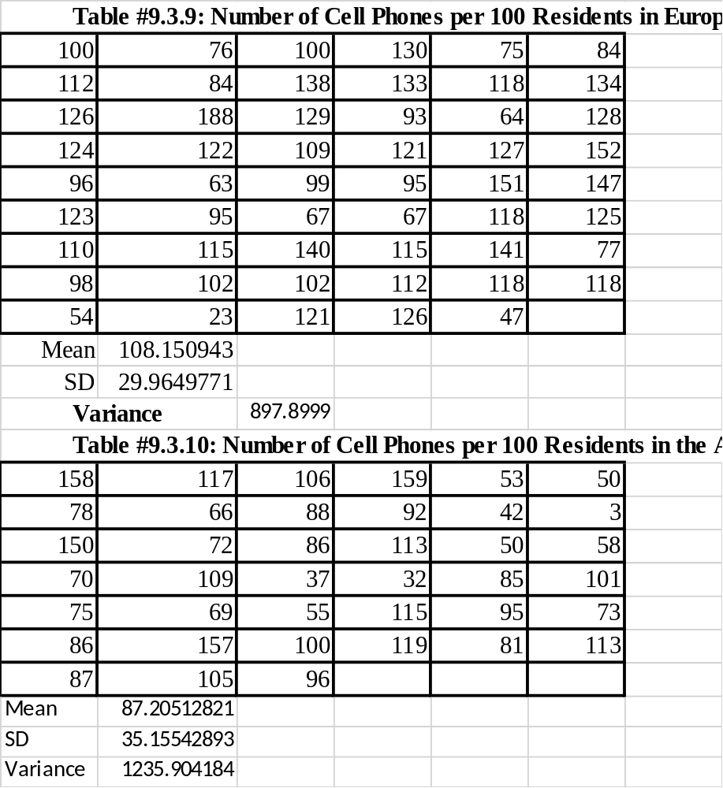
${\overline{x}}_{1} = 108.15; s_{1} = 29.96$
${x̅}_{2} = 87.21; s_{2} = 35.16$
Sample variance
${s_{1}}^{2}=897.9, {s_{2}}^{2}=1235.90$
Checking if$(\frac{{σ_{2}}^{2}}{{σ_{1}}^{2}}>\frac{{s_{2}}^{2}}{{s_{1}}^{2}})≥0.05$ F-distribution test
$=1-F.DIST(1235.90/897.90, 39-1, 53-1, TRUE) = 0.1523$

Because($\frac{{σ_{2}}^{2}}{{σ_{1}}^{2}}>\frac{{s_{2}}^{2}}{{s_{1}}^{2}}=0.1523>0.05$, we assume that the variances are equal
Since the variances are equal, we should find the pooled standard deviation

$s_{p}$=$\frac{\left(53-1\right)897.90+\left(39-1\right)1235.90}{\left(53-1\right)+(39-1)}=$32.26
Degree of freedom(df)$=\left(n_{1}-1\right)+\left(n_{2}-1\right)=90$
$C = 1 – α = 1 – 0.98 = 0.02$, critical value=$“=T.INV.2T(0.02, 90)” = 2.368$

Calculating the margin of error(E)
$E=t_{c}=2.368×\sqrt{\left(\frac{897.90}{53}+\frac{1235.90}{39}\right)}$ =16.517
Confidence Interval (CI)= $({x̅}_{1} - {x̅}_{2} ) - E < (μ_{1} - μ_{2} ) < ({x̅}_{1} - {x̅}_{2} ) + E$
CI=$(108.15 - 87.21) - 16.517 < (μ_{1} - μ_{2} ) < (108.15 - 87.21) - 16.517$
$CI=4. 429 < (μ_{1} - μ_{2} ) < 37. 46$
The mean number of cell phones per 100 residents in countries of Europe is anywhere from 4.429 to 37.462 more than the mean number of cell phones per 100 residents in countries of the Americas
11.3.2
Levi-Strauss Co manufactures clothing. The quality control department measures weekly values of different suppliers for the percentage difference of waste between the layout on the computer and the actual waste when the clothing is made (called run-up). The data is in table #11.3.3, and there are some negative values because sometimes the supplier is able to layout the pattern better than the computer ("Waste run up," 2013). Do the data show that there is a difference between some of the suppliers? Test at the 1% level.
Table #11.3.3: Run-ups for Different Plants Making Levi Strauss Clothing
Plant 1 | Plant 2 | Plant 3 | Plant 4 | Plant 5
1.2 | 16.4 | 12.1 | 11.5 | 24
10.1 | -6 | 9.7 | 10.2 | -3.7
-2 | -11.6 | 7.4 | 3.8 | 8.2
1.5 | -1.3 | -2.1 | 8.3 | 9.2
-3 | 4 | 10.1 | 6.6 | -9.3
-0.7 | 17 | 4.7 | 10.2 | 8
3.2 | 3.8 | 4.6 | 8.8 | 15.8
2.7 | 4.3 | 3.9 | 2.7 | 22.3
-3.2 | 10.4 | 3.6 | 5.1 | 3.1
-1.7 | 4.2 | 9.6 | 11.2 | 16.8
2.4 | 8.5 | 9.8 | 5.9 | 11.3
0.3 | 6.3 | 6.5 | 13 | 12.3
3.5 | 9 | 5.7 | 6.8 | 16.9
-0.8 | 7.1 | 5.1 | 14.5
19.4 | 4.3 | 3.4 | 5.2
2.8 | 19.7 | -0.8 | 7.3
13 | 3 | -3.9 | 7.1
42.7 | 7.6 | 0.9 | 3.4
1.4 | 70.2 | 1.5 | 0.7
3 | 8.5
2.4 | 6
1.3 | 2.9

Solution
Let:
$μ_{1 }=$ mean percentage difference of waste between the layout on the computer and the actual waste of run-up from plant 1
$μ_{2}=$ mean percentage difference of waste between the layout on the computer and the actual waste of run-up from plant 2
$μ_{3}$= mean percentage difference of waste between the layout on the computer and the actual waste of run-up from plant 3
$μ_{4}=$ mean percentage difference of waste between the layout on the computer and the actual waste of run-up from plant 4
$μ_{5}$= mean percentage difference of waste between the layout on the computer and the actual waste of run-up from plant 5
Hypothesis: $H_{0}: μ_{1} = μ_{2} = μ_{3} =μ_{4} = μ_{5}$
$α=0.01$
To find the p-value we conduct ANOVA analysis using excel.

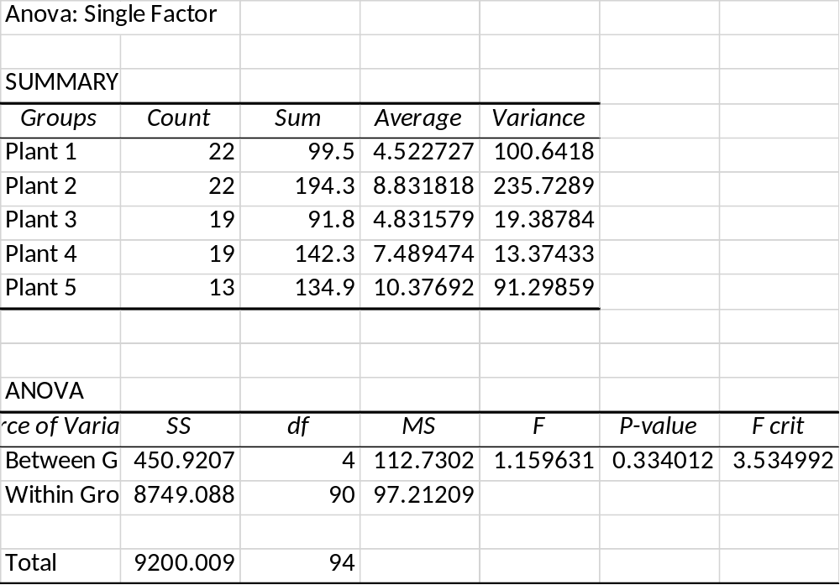

Because the p-value (0.334012) is greater than the significance level (0.01), we accept the null hypothesis. There is no sufficient evidence to show that there is a difference between some of the suppliers

11.3.4
A study was undertaken to see how accurate food labeling for calories on food that is considered reduced calorie. The group measured the amount of calories for each item of food and then found the percent difference between measured and labeled food, 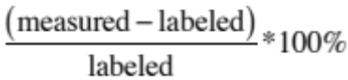. The group also looked at food that was nationally advertised, regionally distributed, or locally prepared. The data is in table #11.3.5 ("Calories datafile," 2013). Do the data indicate that at least two of the mean percent differences between the three groups are different? Test at the 10% level.
Table #11.3.5: Percent Differences Between Measured and Labeled Food
National Advertised | Regionally Distributed | Locally Prepared
2 | 41 | 15
-28 | 46 | 60
-6 | 2 | 250
8 | 25 | 145
6 | 39 | 6
-1 | 16.5 | 80
10 | 17 | 95
13 | 28 | 3
15 | -3
-4 | 14
-4 | 34
-18 | 42
10
5
3
-7
3
-0.5
-10
6

Solution
Let:
$μ_{1}$ = mean percent difference of calories between measured and labeled reduced calorie foods that are nationally advertised
$μ_{2}$ = mean percent difference of calories between measured and labeled reduced calorie foods that are regionally distributed
$μ_{3}$ = mean percent difference of calories between measured and labeled reduced calorie foods that are prepared locally
Hypothesis:
Null hypothesis =$H_{0}: μ_{1} = μ_{2} = μ_{3}$
Alternative hypothesis=$H_{a}:At least one value is not equal$
$α=0.10$
To calculate p –value we perform ANOVA analysis using excel
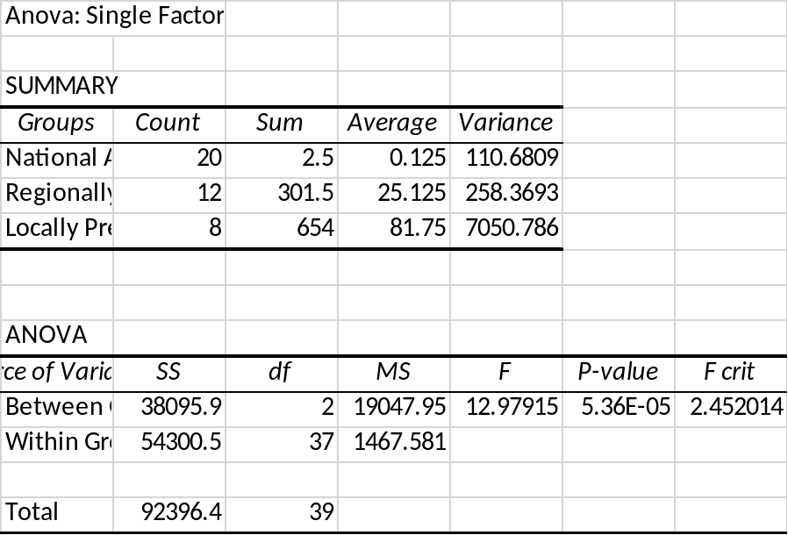

We reject our null hypothesis because the p-value (0.0000536108) is less than the significance level (0.10). There is sufficient evidence to show that at least two percent differences between the three groups are different

